NPS LAB EXPERIMENT-7 ConfigurationofARPandStaticRoutingusingCisconetwork switch and verify the connectivity. Step1:First,open the cisco packet tracer desk to pand select the devices given below

Then, create a network topology as shown below the image. • Usean Automatic connecting cable to connect the devices with others

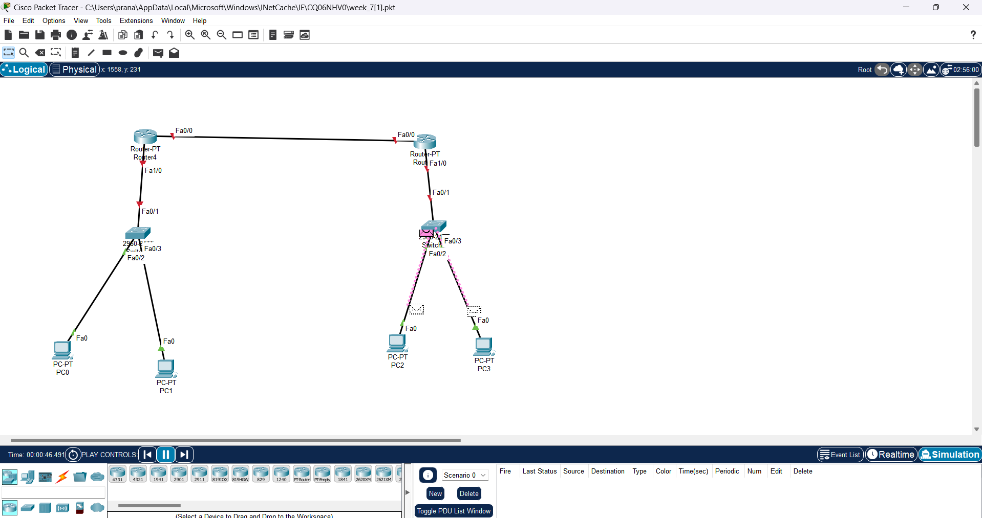

Step 2: Configure the PCs (hosts) with IPv4 address and Subnet Mask according to the IP addressing table given above. •

To assign an IP address in PC0, click on PC0.

•Then, goto desktop and then IP configuration and there you will IPv4 configuration. •

Fill IPv4 address and subnet mask.

Step 3: Assigning IP address using the ip config command. •

We can also assign an IP address with the help of a command.

• Go to the command terminal of the PC

Then, type ipconfig (if needed) Example: ipconfig 192.168.1.3 255.255.255.0 192.168.1.1 • Repeat the same procedure with other PCs to configure them thoroughly.

Step 4: Configure router with IP address and subnet mask.

Toassign an IP address in router0, click on router0. •

Then, goto config and then Interfaces

Then, configure the IP address in Fast Ethernet ports according to IP addressing Table.

• Fill IPv4 address and subnet mask.

• Repeat the same procedure with Router 1 to configure them thoroughly.

Step 5: After configuring all of the devices we need to assign the routes to the routers. To assign static routes to the particular router:

First, click on router0 then Go to CLI. •

Then type the commands and IPinformation given below.

CLI command : ip route

Static Routes for Router0 are given below:

Router(config)#ip route 192.168.2.0 255.255.255.0 10.0.0.2

Static Routes for Router1 are given below:

Router(config)#ip route 192.168.1.0 255.255.255.0 10.0.0.1

Step 6: Verifying the network by pinging the IP address of any PC. We will use the ping command to do so.

First, click on PC1 then Go to the command prompt •

Then type ping • As we can see in the below image we are getting replies which means the connection is working very fine and save the file.

Example : ping 192.168.2.2

